Game Design Document
GAM200-i
DigiPen Institute of Technology
Academic Year 2003-2004
End of the Alphabet presents
Insecticide
End of the Alphabet is:
Max Wagner, Josh Wittner, James Yarrow

Table of Contents
Game Concept 1
Introduction 1
Description 1
Key Features 2
Minimum System Requirements 2
Supporting Technology 2
Story 3
Somewhere in the Wild Jungles of the Midwestern United States… 3
Setting 3
Game Mechanics 5
Sample Game Play 5
Core Game Play / Game Flow 6
Reputation 7
Frontier Towns 7
Stores 8
Districts 8
Taxi 9
Game Modes 9
Single Player 9
Multi Player 9
Server Options 10
Player Design / Characters 10
Ine Sect Abolish 10
Spy DerVanish 11
100 Eyes 11
Tony “Centipede” Sharks 12
Black Widow 12
Combat 13
Player Weapons 15
Weapons Overview 15
Projectile Weapons 16
Weapons Examples 17
Physics 21
Artificial Intelligence Design 23
Overview 23
The Enemy: Insects 23
Brains and Behavior 24
Insect Design 25
Overview 25
Insect Attributes 27
Individual Descriptions 28
Artificial Intelligence Weapons 31
Overview 31
Spit 32
Throw 32
Sting 32
Mandibles 33
Weapon Changing 33
Jump 33
Crouch 33
Status Menu 33
Console 33
Player Interface 34
UI Overview 34
Heads Up Display 34
Menus 36
Visual Art 38
Art Assets 38
Overview 38
Character Models 38
Insect Models: 39
Environment Models: 39
Weapon Models: 39
Other Art Assets: 40
Sounds and Music 41
Sound Assets 41
Overview 41
Player Sound Effects 41
Weapons: 42
Insects: 42
Environment: 42
UI 43
Music 43
Total sound requirement 43
Technical Analysis 44
Experimental Features 44
3D 44
Networked 44
Massive worlds 44
Artificial Intelligence 45
Major Development Tasks 45
Editor 45
First Playable Requirements 46
Risks 46
3D 46
AI 46
Network 47
Time 47
Estimated Schedule 47
Market Analysis 49
Target Platform 49
Target Market 49
Target ESRB Rating 49
Target Genre 49
Top Performers 50
Feature Comparison 50
Legal Analysis 51
Cost Analysis 53
Resource Cost 53
Development Team 53
Hardware 53
Software 54
Revenue Projection 54
Sales 54
Projections 54
Appendix A Feature Priorities 56
A-Level 56
B-Level 56
C-Level 57
D-Level 57
Appendix B Team Sign Off 58
Max Wagner: Producer, Designer 58
Josh Wittner: Technical Director, Art Director 58
James Yarrow: Sound Director, Product Manager 58
Appendix C Copyright Listing 59

Game Concept
Introduction
You: the Orkin Man, on steroids and pain-suppressants, with a couple of Poison Pellet Pistols, air-dropped into the jungle.
Them: Slavering, winged, hairy, crawling, scurrying, and worst of all: very large. Oh yeah, and they’re insects.
Description
Insecticide is a fast-paced first person shooter focusing on action, action, and more action. Set in lush, organic, and otherwise rugged outdoor environments, the world might be thought of as a parallel universe to the Wild Wild West, but with some fancier technology and really bad horse flies.
The player must not only eliminate hordes of swarming insects, but must strive to maintain pest-free zones by rooting out the insects at their very core, the nests themselves. The insects will multiply and employ sophisticated flocking AI to overwhelm the character and create varied, challenging tactical scenarios that the player must overcome. The player has at his or her disposal an array of outlandish tools loosely based on a real-world Orkin employee. Players will be able to compete for glory and reputation.
Key Features
Minimum System Requirements
- Platform: PC
- 1GHz Intel Pentium III or AMD Athlon
- DirectX9 compatible 32MB 3D graphics card with hardware transform and lighting
- 256MB RAM
- Microsoft Windows 2000/XP
- DirectX9 compatible sound card
- Mouse, keyboard
- 4x CD-ROM
Supporting Technology
The core engine of Insecticide will be based upon the Microsoft DirectX 9.0 suite of technologies.
- Graphics Engine
  - Direct3D
- Input
  - DirectInput
- Audio
  - DirectShow
  - DirectMusic
  - DirectX Media
Story
Somewhere in the Wild Jungles of the Midwestern United States…
The year is 1989, and in this day and age in the Midwestern United States trouble comes in many forms. Faced with famine, environmental extremes oscillating between drought and monsoon, and not to mention a massive increase in young children eloping, the inhabitants of this troubled land live hard lives. Furthermore, as the proverbial icing on the cake, they have an enormous insect problem. Enormous, as in these insects are huge bastards. Enormous, as in there’s a whole friggin’ lot of them. The ragged and tattered United States Government sees only one solution to this almost unfathomable insect problem: total eradication. Using advanced technology, including wireless telegraph, the Government sends out a call to all of the world’s best known bug eradicators…
Setting
The overall feel of time and place in Insecticide should immediately conjure associations with the Wild, Wild West of America, a frontier land where regular citizens are afraid to venture beyond the edge of town.
Gun-toting, grim, bounty-hunter types roam the country side, looking for one or the other of two things: money or fame. It’s not a world for the over-sensitive or fragile. Only the best can survive.
Technology finds itself in a hybrid state when compared to what we know as the real world: on the one hand, the milieu of insecticide is set in a rusty, iron-gilded past; on the other, fancy new gadgets abound.
Game Mechanics
Sample Game Play
Crouching in the early dawn under the trees on the ridge, you survey the family of five milling centipedes below. You know that this particular species, the White Eyed Centipede, has trouble seeing in full daylight. Chances are they’re digging for grubs before going back to bed. Finally the sun comes up over ridge to the East and you know this is your best chance to get hold of one, if not more, of their highly prized white, gelatinous eyes.
At the first crack of direct light you’re up out of your crouch, your disposable Raid (Industrial Strength) Spray Cans in your hands, and your Poison Pellet Pistols in their holsters at your sides. Careening down the hill, you jump boulders, side step out of the way of trees, heart pulsing and legs pounding. Half-way down, the acute olfactory senses of the centipedes detects you, and you witness their gargantuan size as all together they rise up on their hind legs. You put away a Raid canister in favor of a Flash Flea Bomb, hoping the blast of light will you give you the advantage by the time you reach the bottom.
Before you know it you’re in full melee combat, sweating and emptying the Raid cans. The smallest one finally drops and writhes before giving up its life. But the other centipedes are ruthless and unrelenting. Wounded, you pull out another Flash Bomb, rip the dead centipede’s eye out of its socket, and run like a bat out of hell for the nearest hold out...
Core Game Play / Game Flow
Game play in Insecticide is fast-paced and action-packed. It combines the shoot-em-up, instant-gratification style of an arcade gun-blazing maelstrom with longer term rewards more usually associated with adventure games, including the acquisition of status and loot.
The pure action-elements form the core of the game play. Melee to mid-range combat with large , frenzied flocks of insects is the norm. Hesitation, ammo-conversation, slow and drawn out strategies are of no use here; your survival depends on being either very fast, or very strong. Intelligence will never be punished of course, and opportunities will arise where a keen and observant player will clearly have the advantage over the casual player; examples include specific insect behaviors and weaknesses, vulnerabilities of certain insects to particular weapons or environmental conditions, as well as such standard tactical conundrums as “Who do I get rid of first?”, given a mixed bag of arthropods chittering around you from all directions.
The longer term, adventure-style elements of the game include the player’s accumulated reputation points, acquired loot and special, rare valuables, and the exploration and control of territory. These aspects of the game allow the player an on-going campaign style of play, with elements of character-development, encouraging the player to reach new goals and levels of success, as well as fostering multiple styles of competition (i.e., not only are you the quickest gun-slinger around, but you control 10 continents are your reputation exceeds the Gods, and you also have a fine collection of wall-mounted insect head trophies).
Reputation
Reputation is a core component of Insecticide, as has already been mentioned. Reputation can be gained through several methods. First of all, each insect-type will have a reputation value attached to it, which upon disposal of said insect will be awarded to the player (some, if not most insects will actually have very little reputation points; they are reserved for the more difficult, legendary of beasts). But an insect’s reputation score is not the final word on how much a player receives; indeed, the method, grace, and skill employed in an insect’s demise are all factored into points won, so that the truly inspired players gain extra bonus points, so to speak.
Reputation is also gained through the acquisition of rare valuables, notably the heads and exoskeletons of bygone insects. Scattered throughout the game will be various highly prized objects which will be added to a player’s permanent collection, thereby increasing the player’s overall reputation score.
The other method of gaining reputation is through District Control. See below.
Frontier Towns
Towns in Insecticide are little more than eye-candy, intended to further the aura/environment of a Wild Wild West style frontier world. Players will be able to walk through the (small) towns and admire the buildings, but will not be allowed to interact with/go into any of them. Naturally, as the citizens are too afraid to venture outside, the player will not be able to interact with them either. The main practical purpose of towns are to provide the player with…
Stores
Stores allow the player to buy new weapons, traps, ammo, repellent: whatever an exterminator would need when in the field. Stores will be handled as UI screens.
Districts
On the frontier, the land has been divided up into districts to make insect-extermination more manageable. Districts are things which are said to be either ‘lawless’ or ‘controlled’. While lawless, exterminators are invited by the locals to save them from their wretched state, and thus lawless districts attract exterminators. But once a district is cleared of nests, it is said to be controlled, and credit is given to that individual responsible for clearing it.
In pure game terms, clearing a district of nests has several advantages. These include a large increase in reputation points, as well as a steady flow of income for as long as it remains under control.
Of course, once a district is under control, it doesn’t necessarily remain that way. They require maintenance as well. The standard form of pest control in a cleared district takes the form of laying traps and bait (more on these later). If a district under the player’s control falls back into the hands of the insects, it is said to be lawless again, and the player will suffer a penalty to his or her reputation.
The number of districts in the game is potentially without limit, though initially a player will only have access to a small handful. As the player gains in reputation, new districts will emerge, as well as entire new islands/areas (or, in conventional terms, “levels”).
Taxi
When out clearing districts of insects, it can be imperative that you’re able to get around quickly. Fortunately, there are ever-enterprising and entrepreneurial individuals who recognize this, and they provide taxi-services to the wounded and weary. Taxis can be encountered at all sorts of strange and unexpected places, to the good fortune of the exterminator. Tales abound of adventurers who thought their lives were over, when taking one more step through the jungle, they crashed through a tangle of leaves only to find a happy, smiling taxi-driver.
In game terms, the taxi can be considered a kind of warp-point. Upon encountering a taxi, a UI menu screen will pop-up, offering various locations, the fees, and the time required to reach each one.
Game Modes
Single Player
Insecticide is in some sense “based” upon its single-player mode. As such, this document is dedicated to the discussion of single-player mode. See below for a discussion of multi-player play.
Multi Player
Multi-player play consists of network play using the client/server model, where individual players can host a game and play on the same machine. Players will also be capable of setting up a dedicated server.
The style of play for multi-player can best be described as full of options controlled by the server. Thus, as server, you could setup a game with small maps, extra-large numbers of bugs, and player alliances enabled. The core components that go into a multi-player game are still the same, the server now is allowed options to control the style of game-play they want to support. Thus, servers could tailor a game to be simply a Death-Match style game, where insects are more of an interesting wrench thrown into the player-only competition, or else a Capture-the-Flag style game, or a time-based game, where the goal is to capture as much loot as possible.
Server Options
Option | Value
Insects | On/Off/Range from few to lots
Weapons | All/Select Styles Allowed
Alliances  -On an individual basis  -No friendly fire | On/Off
Team-Play  -No friendly fire  -Reputation divided evenly amongst team members | On/Off
Map Size | Range from small to large

Player Design / Characters
Ine Sect Abolish
Homeland Russia
Ine was born in Moscow, raised in the USSR, trained from birth as a soldier against the evil bugs prophesied to return after their eradication in 2000 BCE. He is a massive statue molded out of hardships and pain. He works during the day as a butcher, a baker, and a candlestick maker, but trains every night, never forgetting what his father often told him, “To live in peace is happiness, to kill giant bugs is godliness.” He has been waiting for this moment his entire life, and he intends to be known as, “Hero of the Soviet Union.”
Spy DerVanish
Homeland Canada
Spy was born and raised in Vancouver. Having built a reputation as a sneaky devil when he was a little kid playing Hide-n-Go-Seek, Spy was all but forced to follow a career in the Canadian Military. Receiving top scores in marksmanship, sportsmanship, and horsemanship, he was sent off to join the Canadian National Security Agency where his name and life were stripped from him and in return was given a number and the chance to serve the country he loved so much. He was from then on a Secret Agent Man. After many successful missions, most of which taking place in the dense jungles all over the world, Spy became very deft at destroying the bugs that would so often compromise his missions. Then one day, for reasons unbeknownst to the rest of the world, Spy vanished and wasn't seen or heard from again until the United States sent out the call for help with their bug problem. Spy is a walk-on in this endeavor, and he means to take the glory and the cash back home to Canada with him.
100 Eyes
Homeland Unknown
No one knows 100 Eyes real name or where she came from, but everyone knows her by legend. 100 Eyes has a reputation for being able to see all that goes on around her. She’s quick on the draw, some even say too quick, they say she's got to be part bug. She's witty, cunning, devious, and most of all dangerous. Being her friend entitles you to safety, being her enemy is a position most would take care to stay out of. She is to this day the only person who has gone up against an Omphalophagon and come back to tell about it. Stay out of her way and hope that she stays out of yours, because if she doesn't, all odds are on her side.
Tony “Centipede” Sharks
Homeland USA
Born on the Washington coast, Tony spent most of his childhood hunting large sea predators. His father was a shark hunter, his mother was a shark hunter and their mothers and fathers were shark hunters back hundreds of years, but for Tony it never felt right, they were just animals trying to live, and if we didn't harm them they wouldn't harm us. Then one day, after returning home for the summer from school, Tony found his parents and the rest of his clan slaughtered by a giant centipede. After many weeks of fierce battle with this enormous monstrosity, he finally killed the evil insect. He did not come out unscathed though, he had lost his left eye, lost his control over his bloodlust, and vowed to from that day forth to search for and destroy all insects in the world. He is a veteran and he knows more about killing bugs than anyone in the world.
Black Widow
Homeland USA
Sexy, tempting, passionate, audacious, dangerous. Black Widow, affectionately named that by her mother, a huge Alice Cooper fan, took her name to be a foreshadow of sorts to the career she believed she was destined to follow. She has been a professional exterminator since she turned 13. Her and Tony Sharks met at University and had a fling for a short while, but decided that their ambitions to be the best were too high and the competition between them ruined their relationship. Many men have known her, but few have left without the feeling that her name matches her all too perfectly. She is a force to be reckoned with and she aims to bring glory and fame to the name of Black Widow.
Combat
Combat in Insecticide revolves around hit points. Every object that can be damaged has an individual base and current health. In general, the current health of an object is limited by its base health, although special circumstances may apply that push the current health above this normal limit. For example, players may be able to find or purchase power-ups that temporarily grant them extra health. No object, however, can survive dropping below zero hit points: if an object takes sufficient damage to reduce it to this state, it is immediately destroyed with no possibility of regeneration. Otherwise, a damaged object may regain health naturally over time, although not all will.
Since Insecticide aims to implement sub-object level collision, more complex objects may have sub-components with their own hit point values so that location based damage can be applied. Thus in the case of projectile and melee weapons, damage can be calculated at the sub-object level, and then propagated to the parent object where it is applied with a scaling that takes into account the location where the damage was dealt. This allows for the case where non-critical locations on an object (for example, an insect leg) could be completely disabled without killing the insect, since they would pass reduced damage on to their owner, while also permitting the existence of critical locations, that would pass on increased damage to their parent, making for an easier kill with careful targeting. Destruction of non-critical parts on an object will have an impact on that object’s effectiveness: ground based insects that lose legs will move more slowly, for example. Also, once an object loses a component, it may not be restored, even if the parent object normally has regenerative abilities. Damage that does not completely disable an object component will, however, not affect the object’s abilities; it should, however, provide visual feedback to the player so that there is some indication of which elements of an object are damaged.
Objects may have resistances that modify the base damage that is dealt to them. Again, where appropriate, these resistances may be on a sub-object level, in which case the resistance is applied in the location where the damage is actually dealt. No resistance is taken into account when this location applies damage to its parent object. In the case of insects, these resistances are assumed to be the game play representation of the creature’s exoskeleton and will be statically based on the variety and difficulty level of the insect. For the player, these resistances will be based on power-ups that can be found or purchased – similar to armor in other first person shooter games, except with an insect extermination flavor - and will wear out after preventing a certain amount of damage.
Some weapons have special methods of dealing damage. Poison based attacks, e.g. Raid, ignore location based effects and simply deal damage to the affected object itself over a period of time. Instant kill type weapons, such as the Bug Vacuum, immediately cause fatal damage to the affected object on a successful ‘hit’. Resistances may or may not apply to these types of effects.
The Insecticide emphasis on fast combat against multiple enemies indicates that combat balance should be such that a player can take on many insects at one time and still survive the encounter, even when armed with only moderate weaponry. Thus ground-based swarming insects should have significantly fewer hit points than the player and move at comparable speeds. Flying insects will likely move faster, but have this offset by fewer hit points and suicide type attack abilities. This balance should be maintained even in the later stages of the game to maintain frantic game play. More solitary insects such as the centipede, can scale rather differently, since these are intended to be fought one-on-one, and thus may in fact have significantly more health than the player in the more difficult areas of the game.
Player Weapons
Weapons Overview
- Hand to Hand
- Sprays
- Guns
- Rocket Launchers
- Flame Throwers
- Bombs

Projectile Weapons
Name | Range | Projectile mass | Muzzle velocity | Opening angle | Projectile damage | Fire rate | Capacity | Reload time
Q2741 pistol | Short | Light | Med | Small | Small | Moderate | Small | Short
Shotgun | Short | Med | High | Large | High | Moderate | Small | Moderate
Q2741 automatic | Long | Light | High | Very large | Small | Very high | Large | Moderate
PHAT-NOI-SE | Long | Heavy | Slow | Small | Very High | Very Low | Very Small | Long
Shoe | Very short | Med | Slow | Small | Very Small | Very Low | Very Small | Very Short

Weapons Examples
Q2741-VP Handgun
- A revolver firing poison laced slugs. Cheap and readily available thanks to the Insect Act of 1986 requiring all civilians to carry such a weapon at all times when out of doors. Few have ever found this sidearm to be of much use when set upon even by a lone stick insect, but then few have the training to properly use it. Undoubtedly a gun for the master exterminator with finesse and not a little bravado, or else for the unfortunate amateur who's run out of rockets.
Shotgun
- The typical Mid-Westerner doesn't hold much for a pitiful little pistol. He wants a big gun that he can point in the vague direction of a disgruntled termite and be confident that the pest won't be bothering him anymore once he pulls the trigger. What better than a simple shotgun? So it's a little heavy to be carting around all the time, and the accuracy isn't the best, but there aren't many bugs that will get back up after a both barrels have been emptied into its thorax. Of course, the reload time means that he's screwed should he ever have the bad luck to run across a swarm of strawberry hornets, but then to be honest unless his name is Tony Sharks, he's screwed no matter what he's packing.
Q2741-VAR Automatic
- Standard military issue anti-insect weaponry. These heavy automatic weapons employ the same bug disabling venom technologies as the Q2741 handgun. The phenomenal rate with which they can lay down a barrage of fire can sometimes be more terrifying than reassuring, however, since statistics on the battlefield use of these weapons show that 'friendly fire' casualties outnumber enemy inflicted losses by two to one thanks to their rather erratic accuracy.
PHAT-NOI-SE
- Personal handheld arthropod terminator, nuclear ordinance special edition. Though handheld is perhaps a little optimistic, this rocket launching beauty is portable enough to be useful to the exterminator who has the cash and high-ranking military friends required to get hold of one. The rule is that if he's going up against an Omphalophagon, and he doesn't have one of these to hand, then he's not likely to be coming back. The tactical nuclear weapons the PHAT deploys are small enough that proper use should cause no short-term damage, and most people who ever have reason to use one are killed by insects long before any long-term radiation related illness has a chance to set in.
Shoe
- There is something of a difference of opinion among exterminators on how best to die with dignity once one's ammunition is exhausted. One camp asserts that it is preferable to go down fighting, and therefore advocates stripping off one's own shoes and using these as weapons; another group is unable to overcome its disgust at the ignominy of dying in one's socks, and thus recommends simply giving in to fate. It's good to know one's options.
Newspaper
- A rolled up stick of newsprint is the traditional tool for confronting a rampant insect at close quarters. It may seem primitive, but a solid blow to the abdomen can take the wind out of many of the less fearsome six-legged beasts to be found in the American jungles. The danger is that getting close enough to deliver the attack can often involve an unpleasant run in with the enemy's mandibles.
Fly Swatter
- Prototype models for this promising new gadget are hard to come by, but those who have had a chance to test them out universally proclaim the genius of the brain behind this sophisticated extermination device. Building on the concept embodied by the use of newspaper as a weapon, the fly swatter not only increases the area over which an impact will cause damage, but also effortlessly adds to the power of a swipe by means of its flexible handle. While the same downsides that hold back the usefulness of newspaper apply, many exterminators are nevertheless predicting that once it is released to market the fly swatter will become a staple of the bug hunter's arsenal. After all, when just a handful of well aimed strikes can take down an Omphalophagon, it's worth risking a few limbs by getting in close.
Zapp Pack
- Guns have recoil and accuracy problems, melee weapons force you to get within your prey's striking distance, and explosives can be expensive to keep stocked and hard to come by. Where's the smart exterminator to turn? Why, to the Zapp Pack of course. From the people who brought you the Bug Zapper flashlight comes a weapon with a difference. Don't risk your life trying to drill holes in that thick exoskeleton – just fry the critter with a few megavolts. No ongoing costs – after your initial investment of just $1,000,000,000 a handy insect waste powered portable electricity generator will provide all the juice you'll ever need. Buy your Zapp Pack today!
Bug Vacuum
- Running on the same technology as the Zapp Pack for efficient use of insect remains as fuel, the Bug Vacuum enables an exterminator to quickly clear an infested area by simply sucking up the pests. Particularly recommended for smaller insects, especially airborne ones; larger beasts may be hard to knock off their feet thanks to their greater mass, and the airflow is at least as likely to annoy them as a bullet wound without any of the attendant advantages.
Raid Spray
- Not a handheld canister. This device resembles a flamethrower in that it is designed to expel fluid at high velocity over a large enough range that the user is unlikely to sustain injury. Any young, elderly or infirm insects coming in contact with this fluid are likely to die instantly, and even healthy adults will be severely disabled. Users are advised to avoid sprayed areas until the gas has dissipated. In case of inhalation, contact a physician immediately.
Raid Grenades
- An alternative method of deploying Raid. These grenades use a small explosive charge to spread toxic gas within a radius of several feet. The additional damage from the explosion and the simpler to manage area of effect are traded off against a much lower possible rate at which one can lay down poison. Probably best used as an auxiliary weapon.
Physics
In order to create an immersive simulated environment, Insecticide requires a detailed physics engine. Every mobile object in the game, from the giant Omphalophagon to poison grenades, to the player character his or herself, will have physical properties that govern its movement. A key point here is that the actual values of these physical properties are not necessarily based on real world objects. The important aspect of the physics engine is to ensure that motion has a believable shape or pattern, not that it conforms exactly to reality in dimension: in fact the more fantastic elements of Insecticide would seem to indicate that the physics based effects should be somewhat over the top in nature.
At the very minimum, all objects should carry mass to enable momentum based collision calculations. For example firing a projectile weapon will apply a recoil to a character based on the projectile's mass and muzzle velocity as well as the character's mass. Thus, a small character firing a heavy weapon might fly backwards, while a heavier character might barely move. A side effect of this system is that continued firing will become progressively less accurate as the player is driven backwards by recoil but the opening angle on the projectiles remains constant. Other visible features of the physics include explosive weapons actually applying force to objects and flying insects being knocked off course by projectiles.
A robust physics system leaves room open for physics based power ups, which could be made available through the in-game store. Possibilities include spiked boots for increased traction, reducing the effect of weapon recoil, or banana skin shoes, for just the opposite effect.
Accuracy in collision detection is perhaps even more important than accuracy in collision response. Even when on screen in large numbers, insects need to appear to correctly collide with each other as well as static objects in order to maintain suspension of disbelief. Detection should take place on a sub-object level, allowing for location based damage. Additionally this paves the way for later addition of sub-object collision response in which physics calculations are applied to the object's skeleton, opening up new tactical options in game play such as shooting out an enemy's legs.
Terrain in Insecticide consists of simple height maps with no overhangs. Thus, with the exception of flying insects, objects in general have a predictable height dependent only on their location in the world. This simplifies terrain collision and has the result that gravity need only be applied when objects are detected to have left the ground either as the result of a jump or a collision. Line of sight for insect AI should, however, be obscured by terrain which will require the ability to collide accurately against the height map. As an optional additional feature, all collision with the terrain could be updated to use this more precise collision, possibly thus allowing for more three dimensional levels.
Artificial Intelligence Design
Overview
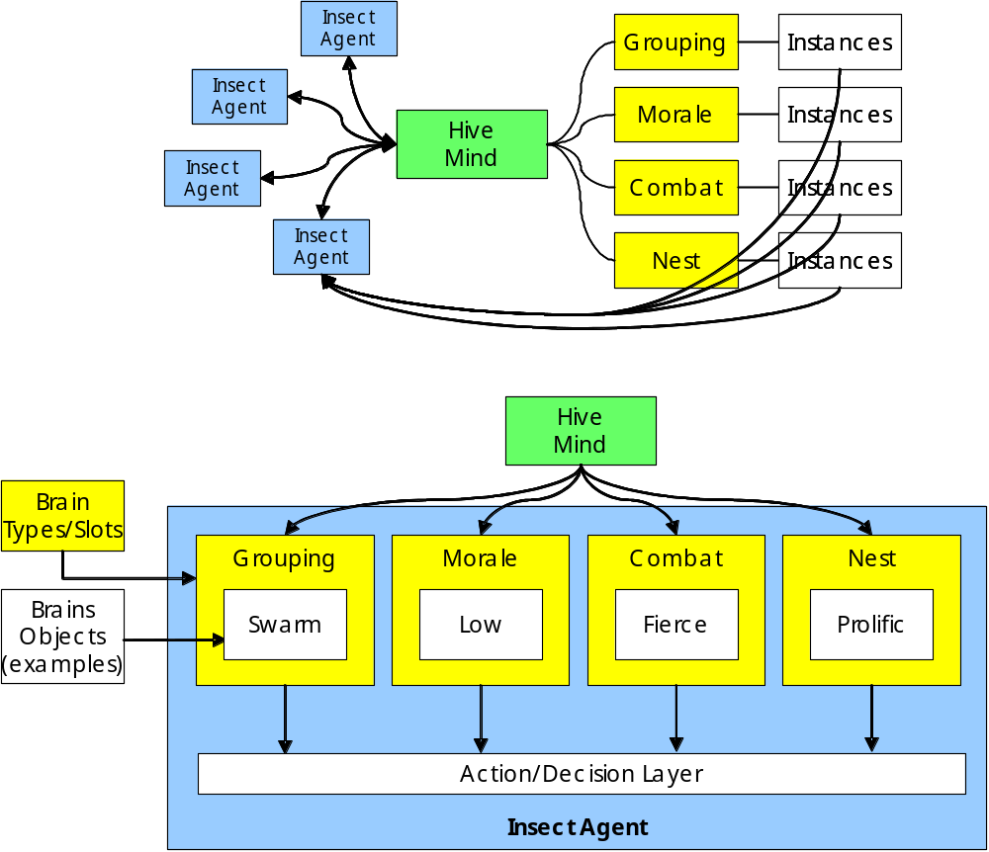
The Enemy: Insects
Insects can have a variety of behaviors, all of which come from a combination of different instinctual behaviors. The bugs in our game will come in a variety of the same sorts. There will be different motion behaviors, different fight or flight instincts, different in-combat behaviors and different hive-development behaviors.
Brains and Behavior
Motion Brain
- Bugs will have several different motion AI's. There will be bugs that flock together in large groups, bugs that march together like ants, bugs that act in small packs, and bugs that stray on their own. This offers to the player many different styles of encounter, they may find 1,000 bugs at once, and have to scramble to kill them all, or they could stumble into a lone giant and fight for a while versus a much stronger foe, or even find a small pack of giant ants that need to be taught a lesson.
Fight or Flight Brain
- Insects in the real world have a natural instinct to run or to fight, in any situation. In Insecticide we will model our insects after this fact. Some insects will lean towards running from the fight depending on the number of backup it has while others will always fight, or always run. Insecticide will also give bugs the instincts to realize when it is time to run, if already in a fight, and when it is time to fight if it is already running.
In-Combat Brain
- Insecticide will feature bugs with several different fighting styles. There will be bugs that all out charge you, bugs that stay back and spit at you, bugs that try and tag team fight you, bugs that will try and pick at you little by little, and bugs that will sacrifice themselves to destroy you. Also bugs will be smart enough to run if they think their losing, smart enough to charge if they think your down for the count.
Nest-Development Brain
- Some bugs will proliferate more often than others, which will enlarge their hive, some will have a natural predisposition to build new hives, some will be controlled by a central intelligence while others develop on their own. Some will be territorial while others will be more aggressive in moving away from the hive.
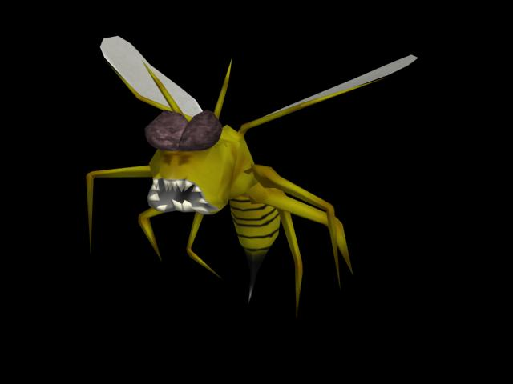
Insect Design
Overview
Many different varieties of arthropod, not limited to class Insecta, make their homes in the wilds of the Midwestern United States, each with their own individual attributes, skills and behaviors. These attributes encompass speed, strength and mass, together with aptitudes at detecting threats via sight, smell or sound. For comparison purposes, an exterminator at the very apex of the profession might have a rating of 50 in each of these attributes. Also, these numbers define only a base level of ability for each insect variety. An individual type, however, is further divided into subspecies which may stray somewhat from the default attributes for a variety. In addition, those of these species that typically live in large social groupings, will be further divided in ability based on their position within that insect society. Thus an exterminator may come across drone, worker, hunter, soldier and queen ants, which may be either red or black, and each will present a different challenge to the player, though all will have attributes based on the statistics listed here.
The behavior of an insect variety determines the type of AI brain that it will typically subscribe to. Insects that favor group based behavior will take decisions that take into account the actions of their compatriots, while solitary types will behave more independently. This distinction carries across even into behaviors that are not specifically motion related such as combat decision making. The insect variety also, however, determines the skew of the AI brain towards fight or flight as well as its propensity to develop new hives and thus increase insect populations regardless of whether the brain itself be group or individual oriented. Thus when a spider encounters a player, it will make the decision on whether to engage in combat or run for the hills with reference to the states of local members of the same species, and this decision will be weighted towards a cautious response rather than a frontal assault. A disturbed centipede on the other hand will likely charge down an aggressor regardless of any kin it may have in the area.

Insect Attributes
(numbers as percentages)
 | Attributes |  |  |  |  |  | Brain Categories
 | Speed | Strength | Sight | Smell | Hearing | Mass | Grouping | Morale | Combat | Nest-Development
Centipede | 50 | 85 | 20 | 70 | 50 | 80 | Solitary | High | Fierce | Low
Hornet | 70 | 40 | 50 | 50 | 90 | 25 | Flock | High | Fierce | Medium
Beetle | 30 | 80 | 50 | 50 | 50 | 50 | Solitary | Low | Mild | Medium
Ladybug | 35 | 80 | 50 | 80 | 70 | 70 | Solitary | Low | Timid | Low
Dragonfly | 90 | 60 | 95 | 45 | 85 | 35 | Solitary | Low | Fierce | Low
Fleas | 90 | 30 | 20 | 10 | 35 | 5 | Flock | High | Fierce | High
Houseflies | 60 | 50 | 100 | 80 | 90 | 20 | Variable | Low | Mild | High
Spiders | 80 | 40 | 10 | 70 | 80 | 30 | Family | Low | Mild | High
Ants | 15 | 80 | 65 | 90 | 10 | 20 | Pack | High | Fierce | High
Omphalophagon | 100 | 100 | 100 | 100 | 100 | 100 | Solitary | High | Fierce | None

Individual Descriptions
Houseflies
- Houseflies are generally a mild opponent, though these are slightly larger and more violent than the houseflies of yore. These lazy-flying, bloated beasts like to pick on slow-moving or still objects, and will swarm around masses of dead and decaying bodies, often ex-exterminators.
- Special Abilities include flight and acute sense of smell.
Spiders
- Insecticide, though technically a game about exterminating insects, would not be complete without members of the arachnid family. Spiders are notorious for their secretive manner, hiding in forests and laying traps for their unsuspecting foes in the form of hard-to-see webs. Other breeds, however, prefer the crags of mountain rocks. Spiders reside in families, with one mother and usually a large pack of smaller, less powerful children.
- Special abilities include web making.
Ants
- Ants are a chronic pest in the world of Insecticide, traveling in huge columns, marching and carrying on in their organized and militaristic ways. It is common for ants to pillage human villages and take with them all the food in the area. An ant by his or herself may pose no threat and may in fact break and flee, but rarely will an ant be encountered so. Usually, a column of ants can be seen filing along the ridges of mountains from very far away.
- Special abilities include spitting.
Fleas
- The pursuer of pursuers, the hunter of hunters, the flea is the underestimated enemy of all things good and right in the world. It will stalk you day and night, through all weather conditions, with no thought as to its own safety, and once it finds you, well lets just say you'd better have a Raid grenade or you’re gonna have a hard time getting rid of your new itch. The flea is the smallest of all insects to be found in the United States, but what they lack in size they make up for in persistence and sheer number. So if you hear a rumbling coming, but you can see nothing but a dense cloud on the horizon, you best start running backwards and chucking bombs cause if you get caught, which you probably will, this is the most difficult of pests to kill.
- Special abilities include flight and extreme swarming.
Dragonflies
- Known around the world for their intense speed and sudden changes in direction, the dragonflies of the Mid-West are both dangerous and cunning. Quick on the move and cunning, the dragonfly uses a tactic known as “Motion Camouflage”, with which the dragonfly is able to provide the illusion of staying in one place while really drawing ever and ever closer to you and your inevitable doom. If you see one coming, but think to yourself that you have plenty of time to get out of the way, then you’re already dead, no money and no glory, just dead.
- Special abilities include motion camouflage.
Ladybugs
- Beautiful, majestic, enchanting. The ladybug provides its victims with a sense of completeness, just before it opens its wings and bites the victim’s head off with its sharp over-sized jaws of death, or that’s the story 100 Eyes tells. The general rule is stay clear of them and they'll stay clear of you, but then again, your job is to kill, and if you just stayed away, what kind of a worthless exterminator would you be. Caution is advised, however, for the real habits of the ladybug are unpredictable. You very well may kill one without a fight, but the next time you run into one with your guard down will probably be the next time you die.
- Special abilities include limited flight and bite.
Centipedes
- One of the great unsolved mysteries of entomology is whether these terrifying beasts do in fact have one hundred legs. No-one has ever caught a living specimen, and centipedes' incredible resilience means corpses are inevitably too severely mutilated to offer any conclusive evidence. Exacerbating the problem is the fact that these solitary predators are rare, and even seasoned exterminators are unlikely to have encountered one. As a result, the centipede eye is a highly prized trophy, marking its owner as a man unafraid in the face of even the most slavering of mandibles. Ironically, this same eye is almost useless to the centipedes themselves, who rely instead upon a highly developed sense of smell to detect their prey. In fact, the eye can be said to be a hindrance to them, as they become blinded during daylight hours.
- Special abilities include high health and damage resistance.
Hornet
- Ahh the hornet. These swarming insects are cocky and aggressive. It is a rarity to find them alone, but you better hope that you do because no other group of insects is so ready and so willing to fight for its territory than a swarm of hornets. They'll sting, they'll bite, they'll over-all just look intimidating, and their guaranteed to leave you with more than just a welt. A giant flock of these carnivorous winged beasts is no job for a couple of poison pistols, we at End of the Alphabet strongly suggest the Bug Vacuum for a job of this magnitude.
- Special abilities include flight and sting.
Beetle
- The beetle is the most average bug you'll ever meet. Not too fast, not too slow, not too smart, not too stupid. Their main attribute is their ability to burrow in the ground and sit and wait for some unexpecting civilian to get too close, which is when they will leap from the ground (albeit slowly) and attack their prey. Dangerous only because of their incredible strength, the beetle is one bug that even a beginner should be able to take care of even if they do fall into the beetles' trap.
- Special abilities include extreme strength.
Artificial Intelligence Weapons
Overview
Insect weapons fall into four categories, each one associated with specific varieties of insect. In calculating the speed, accuracy, etc. of a particular insect attack, both the intrinsic properties of the attack type, and the particular variety of insect are taken into account. Thus a hunter ant will have a faster and more accurate spit attack than a drone. Attack types, their properties and some of the insect varieties that employ them are listed below.
Spit
(Ants)
Some insects can propel acidic fluid over short distances. This attack has high accuracy and damage but a fairly limited range. Most insects can spit only slowly, since their glands must replenish their supply of fluid each time they attack. A few more deadly varieties can, however, amass large reserves of acid, allowing them to spit much more rapidly in combat.
Throw
(Beetles)
While the prehensile abilities of insects pale in comparison to those of humans, some varieties can manipulate their environment sufficiently well to propel material fast enough to cause minor damage. Alarmingly, some can even do this extremely rapidly, transforming this ability from a minor annoyance to a serious threat. This attack is much faster than spit and effective over a greater distance, but deals little damage per hit and is much less accurate.
Sting
(Hornets)
The most feared of all forms of insect weaponry. Insect stings are highly damaging, but in most cases are melee weapons only. Many insect varieties lose their sting upon delivery and die almost instantaneously as a result.
Mandibles
(Centipedes)
Some insects have powerful jaws that can crush a human easily should they be unwise enough to get within range. Thankfully, no insect has yet found a means of using these weapons over any kind of range, so in theory all an exterminator must do to stay alive when fighting such creatures is be fast on his feet. Often, however, this is hard to put into practice, for in many situations one hundred feet are better, and faster, than two.
Weapon Changing
The player will be able to easily switch between weapons.
Jump
The player will be able to jump.
Crouch
The player will be able to crouch.
Status Menu
The player will be able to bring up the status of their sectors as well as give them further access to other menus and options.
Console
The player will be able to access the console and see some information about what the game is currently doing. Note that this is for advanced player information.
Player Interface
UI Overview
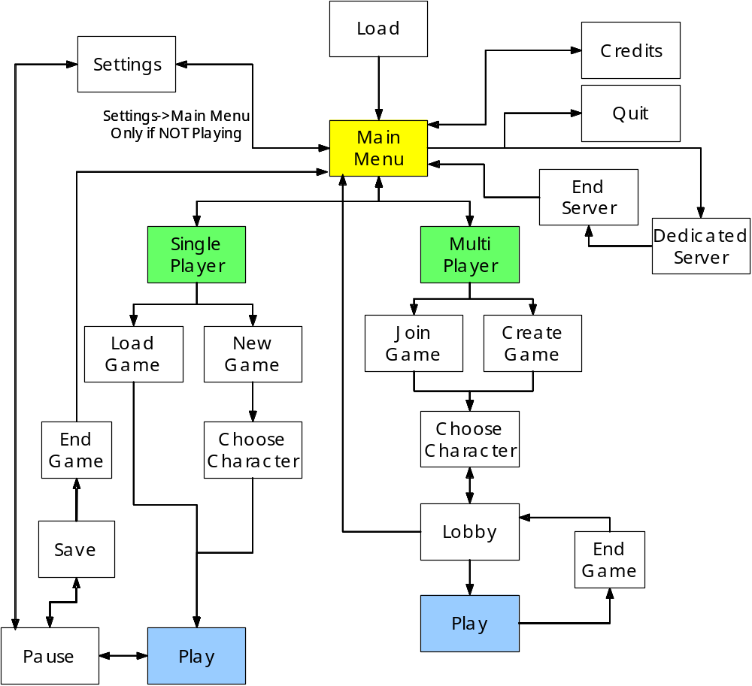
Heads Up Display
As a first person shooter style game, Insecticide relies heavily on having a large fraction of available screen real-estate devoted to actual game play. User interface elements should be as unobtrusive as possible to minimize clutter and allow the player to have a clear view onto the action. In order to achieve this goal, Insecticide divides its user interface into modular panels or windows. For example, a single panel would display the player's current health and armor levels, another might show the ammunition remaining for the weapon the player is using, while a third might show a radar pinpointing the locations of nearby insects. While several default arrangements of these panels are available, players will also be able to customize the layout and add or remove additional panels to suit their own preferences. Each panel is fully draggable and can be positioned anywhere on the screen, and may also be switched on and off independent of other panels. This facility can be accessed either outside game play through the options menus. Alternatively, the player may during a game hold down a user designated key to temporarily halt game play and display the cursor. The full complement of in game user interface panels will be displayed, and the player will be able to reposition them and lock or unlock each of them to determine whether it persists when the key is released. This latter feature is similar to the ability in other first person games to overlay game information and statistics typically by holding the TAB key. Panels can also be hot-keyed so that they may be quickly toggled on and off during game play.
The current list of user interface panels encompasses:
- Health/Armor: The player's current health and armor level.
- Ammunition: The available ammunition for the currently active weapon, divided into ammunition available until a reload is required, and total ammunition available, where appropriate.
- Radar: A small circular radar indicating the locations of nearby insects. Other points of interest, e.g. taxicabs, stores, airdrop locations, active and inactive traps are also marked. Blips are color-coded to ensure that players can easily distinguish them.
- Map: A small scale map of the entire level. Similar to the radar, it has current location, stores, taxicabs, and active traps and events marked with color coded symbols.
- Cash/Reputation: The player's current cash balance and their exterminator standing.
- Active traps/events: A listing of all traps that contain insects awaiting extermination, together with all ongoing random events. Each entry in the list displays an arrow indicating the direction to its location, a time until it expires and the estimated minimum on foot travel time from the player's current location.
- Alert history: A log of recent messages received through the alert panel (see below).
Other panels may be added as needed.
Additionally, there is one further panel that may be repositioned, but not switched off. This is the Alert panel, which displays messages when insects are successfully trapped or when news of a random transient event is received. This panel is not normally visible, but pops up briefly whenever a new message is received.
Menus
'Menus' in Insecticide are user interface elements that expect input from the player, rather than simply displaying information. Unlike the panels of the HUD, menus are modal, i.e. all input is routed through the currently active menu until it is closed. Menus called for by the user interface design are:
- Title screen/main menu
- Options menu
- Load menu
- Save menu
- Credits
- Character select: Allows the player to select and name a character for a new game.
- Level select: Allows the player to select an area in which to hunt insects. Availability of levels depends on reputation.
- Equipment store: Allows the player to buy new weapons and equipment as well as replenish ammunition in exchange for cash.
- Taxi destination select: Allows the player to select a taxicab location to travel to in exchange for cash.
- Statistics: Displays statistics on the current character's achievements.
- Exterminator rankings: Lists exterminators by cash and reputation.
Visual Art
Art Assets
Overview
Insecticide uses the custom built .ixm model format which contains support for either static or skeletally animated single-textured models. Models should be created in Discreet’s 3DS Max and exported to the .ixm format using a plug-in. Animations should be produced by inserting bones into the model such that no vertex is affected by more than two bones and then animating the skeleton. Animations can be exported independently and then recombined with the mesh in the Insecticide Editor. Acceptable polygon counts vary depending on the in-game function of the object: initial tests suggest that detailed characters could consist of up to 2000 triangles, while insects that typically will be encountered in swarms should target 800 or lower. Texture information is converted to a custom format and incorporated in the model file produced by the Editor. All standard image formats, including bitmaps, JPEG, TGA, and PNG are supported. While capability for an alpha channel in the model texture is provided, use of this should be avoided where possible to minimize complexity.
Character Models
- Ine Sect Abolish
- Black Widow
- Spy DerVanish
- 100 Eyes
- Tony “Centipede” Sharks
- Note: If programmers do the art, we reserve the right to use one model for all characters.
Insect Models:
- Omphalophagon
- Hornets
- Beetles
- Centipedes
- Ants
- Flies
- Variety of nameless creations
- Note: If programmers do the art, we reserve the right to use one model for all insects.
Environment Models:
- Rocks
- Trees
- Shacks (houses)
- Note: If programmers do the art, we reserve the right use the same model for all rocks, the same model for all trees, and the same model for all shacks.
Weapon Models:
- Q2741-VP Handgun (revolver)
- Shotgun
- Q2741-VAR Automatic
- PHAT-NOI-SE (Personal handheld arthropod terminator, nuclear ordinance special edition)
- Shoe
- Newspaper
- Fly Swatter
- Zapp Pack
- Lightning
- Bug Vacuum
- Raid Spray (like a flamethrower)
- Raid Grenades
- Spit (insect weapon)
Other Art Assets:
- Ammo Boxes (models and textures)
- Dead bugs parts (models and textures)
Sounds and Music
Sound Assets
Overview
For highest quality, sound effects should be captured as .wav files sampled in stereo at 44kHz. Music files should be compressed to MP3 format at 96 kbps.
Player Sound Effects
- Run
- Walk
- Move when crouched
- Jump
- Hurt x 5
- Hurt badly x 3
- Low on health
- Death
- Collect health
- Collect armor
One set for each character.
Estimate 5 characters.
Total = 16 * 5 = 80
Weapons:
- Pick up
- Pick up ammo
- Select
- Fire
- Out of ammo fire
- Reload
One set for each weapon (duplicates possible)
Estimate 10 weapons
Total < 6 * 10 = 60
Insects:
- Idle x 3
- Alerted
- Scared
- Hostile
- Hurt x 5
- Hurt badly x 3
- Low on health
- Death
Estimate 5 sets.
Total = 16 * 5 = 80
Environment:
- Misc x 25
Total = 25
UI
- Mouse over
- Activate
- Buy x 5
- Take taxi x 3
Total = 17
Music
- Background x 5
- Title theme
Total = 6
Total sound requirement
- Approx 250 sound effects.
- Approx 6 tracks of music.
Technical Analysis
Experimental Features
3D
This will be the first game that any of us at End of the Alphabet has worked on that was fully 3D. Getting a 3D engine up and running using the tools of today is not very difficult, however, getting an engine running that runs quickly and smoothly with as much detail and refinement as needed for a project as great as ours will take some ingenuity and hard work. We will be using Direct 3D, but will be trying to avoid any use of the D3DX functions, functions well known to do a lot of the graphics work for you.
Networked
This will be the first time that two of the three members at End of the Alphabet have worked on a networked game. We are planning on building the server into the client application so that any user that runs the game can be the server, or if they wish start and run just the server from the client interface. This will allow the user to either run a dedicated server or not. See multiplayer section for more info.
Massive worlds
Insecticide will feature vast worlds in Single Player mode with the option to scale them down in Multiplayer. This is an experimental feature in that we are planning to provide a fast paced action-shooter in vast open environments. This is not generally found in the FPS genre for many reasons. One being that to have vast environments while at the same time providing many enemies and great AI (see #4) is a task not easily accomplished; a second reason is that giving the player that much area to move in does not provide a focus of attention at accomplishing goals that most First Person Shooters try to maintain. This, however, is exactly what we at End of the Alphabet are trying to do, we wish to give the player the option of trying to accomplish the eradication of all the bugs on the current map in whatever fashion he/she wishes. Big open areas allow us to give the player that freedom.
Artificial Intelligence
Insecticide will feature many kinds of Artificial Intelligence that goes beyond the team’s previous work. We plan on implementing various flocking AI's, combat AI's, hive development AI's, and fight or flight AI's that will push the bounds of DigiPen Artificial Intelligence.
Major Development Tasks
Editor
The editor will be where most of the first semester’s time is spent on Insecticide. The editor features 4 different editing features:
- Terrain Editor
- Animation, Modeling, Particle Effects Editor/Viewer
- User Interface Resource Editor
- Font Pack Editor and Builder
First Playable Requirements
The first playable is due at the end of the first semester, being so there are many major development tasks that are needed for such a thing to be delivered:
- Art development
- 3D graphics engine optimization
- User Interface Resource creation
- Terrain Creation
- AI implementation
- Combat implementation
- Physics implementation
Risks
3D
One of the major risks of this project is that this is the first fully 3D project that any of the members of End of the Alphabet have worked on. This is a major risk, but is currently one of less worry for the members working on the project.
AI
This will be the biggest artificial intelligence project that any of the members have worked on as well. We are hoping to provide a vast difference in behavior for the insects in the game by providing different combinations of AI's. This is a very definite risk, but with our ability to work as an effective team, End of the Alphabet is sure to provide.
Network
Networking is a big risk because we are planning to provide vast worlds with fast action and good AI, so keeping all clients in sync with as little slow down as possible is a big concern for our game.
Time
Time is always a risk and there is some risk that the project we have planned cannot be accomplished in the time provided. There are currently contingency plans in place to handle this risk:
Reducing the number of the weapons if that becomes too time consuming of a problem.
Reduce the number of possible multi-player players, which will help with many networking issues we might run into if we cannot solve in time.
Reducing the number of bugs to increase game play speed if slow down becomes an insurmountable problem.
Estimated Schedule
- First Playable: December 5, 2003
  - Graphics Engine: 70%
  - Physics Engine: 40%
  - Networking: 50%
  - AI Engine: 30%
  - UI Engine: 30%
- Alpha: February 20, 2003
  - Graphics Engine: 95%
  - Physics Engine: 90%
  - Networking: 90%
  - AI Engine: 80%
  - UI Engine: 80%
- Beta: April 9, 2003
  - Graphics Engine: 100%
  - Physics Engine: 100%
  - Networking: 100%
  - AI Engine: 100%
  - UI Engine: 100%
- Gold: May 7, 2003
  - Graphics Engine: 110%
  - Physics Engine: 110%
  - Networking: 110%
  - AI Engine: 110%
  - UI Engine: 110%
Market Analysis
Target Platform
PC under Microsoft Windows OS
Target Market
Insecticide targets the action-oriented segment of the market, but also through its sophisticated insect artificial intelligence extends its appeal to players who appreciate thoughtful, tactical play. The emphasis on distinctive enemy behaviors, together with expansive outdoor environments, over the top physics and a light-hearted presentation set Insecticide apart from existing and upcoming games in its genre such as Quake, Half-Life, Half-Life 2 and DOOM. To ensure the widest possible audience compatible with the game concept, Insecticide is targeting an ESRB rating of Teen. Projected content includes animated violence, animated blood and mild language.
Target ESRB Rating
Teen for violence, animated blood, and mild language.
Target Genre
First Person Action Shooter
Top Performers
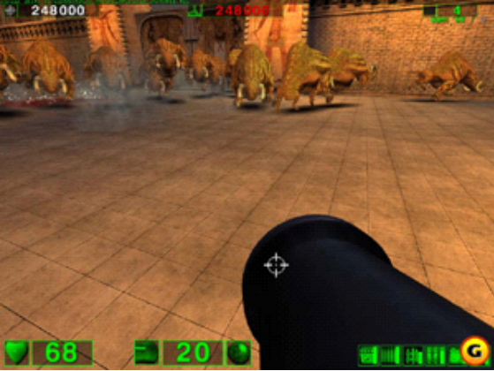 | 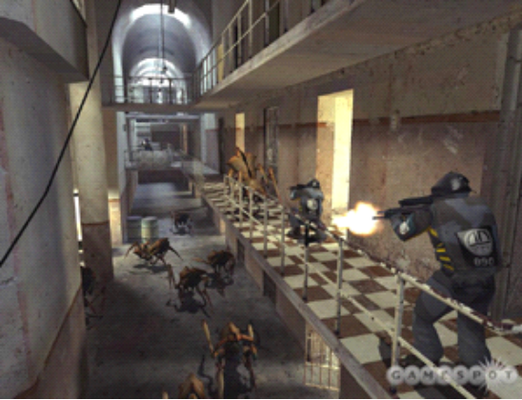
Serious Sam: The First Encounter | Half Life 2

Insecticide falls into a competitive genre in the PC market. These competitors include Serious Sam for its similar emphasis of large scale, swarming battles, Half Life and Half Life 2, both shooters with strong single player components, as well as the Quake and Unreal flavors of FPS games.
Insecticide sets itself apart from its competition with its unique blend of open-air light-heartedness and intense, insect-blasting mayhem.
Feature Comparison
Insecticide features many of the now famous elements that many First-Person Shooters have. Our game play will be fast-paced “twitch” game play, similar to that of Counter-Strike or other Half-life mods. We will feature massive number of enemies to kill at one time somewhat similar to that of Serious Sam, but on an even higher level. We will feature an upgrading element that you often find in your story-based First-Person shooters like Deus Ex, but not to that deep of an extent; this element will mostly come in the ability to buy better weapons, traps, health, etc. as the player gain the cash and the reputation to attain them. Our game will feature a variety of weapons that along with traps and other items will give the player the satisfaction of either becoming champions of certain weapons (see Weapon Description: Q2741-VP Handgun) or trying to use all the weapons at their disposal more effectively to destroy every bug in existence. This is a feature that many First-Person Shooters have done well.
Insecticide will feature aspects of game play, though, that are not often found in your normal First-Person Shooters. Our massive worlds which give to option to the player of exterminating how, when and where they wish, thus giving the player almost all control over how difficult the current level is. The massive worlds give a bigger sense of reality to the not so real world we have placed them in, like the worlds of many Massively Multiplayer Online RPG's without all the wasted walking around time. The day-night cycle gives the player a real sense of a living thriving world, because the insects will be affected by this cycle in ways such as awareness, sight, hearing, etc. The world and game play will change from day to night, as dictated by the various insects’ sensibilities to light and diurnal/nocturnal habits. This feature is a new idea amongst first-person shooters as far as we know.
Legal Analysis
Owing to the obscurity of the game design, we see little chance of stumbling into any legal problems. Because of the small number of people at End of the Alphabet, it is easy to make certain that no intellectual property is infringed upon, and that all ideas come from the members of the team itself. Records will be kept to make certain that this does not happen, and should it occur End of the Alphabet is prepared to make any changes to the design as is needed to settle the problem.
Cost Analysis
Resource Cost
Development Team
Name | Position | Annual Salary | Months | Cost
Max Wagner | Producer/ Designer | $60k | 7 | $35k
Josh Wittner | Tech & Art Director | $60k | 7 | $35k
James Yarrow | Product Manager/ Lead Tester | $45k | 7 | $27k
Grand Total Cost |  |  |  | $97k

Hardware
Item | Number | Cost | Combined
Workstation | 3 | $1,200 | $3,600
Total Cost |  |  | $3,600

Software
Item | Number | Cost | Combined
Microsoft Visual Studio .NET 2003 | 3 | $1,079 | $3,237
Discreet 3DS Max 5.1 | 1 | $3,105 | $3,105
Total Cost |  |  | $6,342

Revenue Projection
Sales
As a first person action shooter Insecticide targets a large portion of the PC gaming market, and we therefore suggest the mass market retail price of $49.99, with estimated sales of 150,000 units.
Projections
Assumptions | Value
Sales | 150,000
Development cost | $106,942
Additional cost to publisher | $500,000
Publisher revenue per unit | $40
Developer royalties per unit | $3
Revenue Projection | Value
Total publisher revenue | $6,000,000
Breakeven units | 15,174
Royalties due | $404,479
Total publisher profit | $4,988,579
Sales | 150,000
Development cost | $106,942
Additional cost to publisher | $500,000

Appendix A
Feature Priorities
A-Level
- District based game play
- Multiple levels
- Reputation based level advancement
- Traps
- Multiplayer
- Multiple weapons
- Multiple insect varieties
- Multiple insect AIs
- ‘Hot-swappable’ insect AIs
  - depends on ‘Multiple insect AIs’
- Parameter based physics
B-Level
- Random events
- Day/night cycle
- Insect development
- Sub-object level collision
- Location based damage
  - depends on ‘Sub-object level collision’
C-Level
- Server-controlled game options
- Customizable UI
- Full complement of multiplayer options
- Full complement of weapons
- Full complement of insect varieties
- Location based ability modification
  - depends on ‘Location based damage’
D-Level
- Quake-style console
- ‘Style’ based reputation system
- Day/night dependent AI (
  - depends on ‘Day/night cycle’
  - depends on ‘Hot-swappable insect AIs’
- Procedural Animation
  - depends on ‘Sub-object level collision’
Appendix B
Team Sign Off
Max Wagner: Producer, Designer

Josh Wittner: Technical Director, Art Director

James Yarrow: Sound Director, Product Manager

Appendix C
Copyright Listing

© ORKIN Exterminating Company, Inc.
© Intel Corporation
© Advanced Micro Devices, Inc.
© Microsoft Corporation
© Microsoft Corporation
© S.C. Johnson & Sons, Inc.
Discreet and 3DS max are either registered trademarks or trademarks of Autodesk Canada Inc./Autodesk, Inc. in the USA and/or other countries. All other brand names, product names, or trademarks belong to their respective holders.

